**AGRESSO GUIDE**

**GOODS RECEIVED NOTE (GRN)**

When Goods are received a Goods Received Note (GRN) should be generated at the time of delivery to facilitate prompt payments to Suppliers.

# **To generate a GRN**

1. Enter the Order Number
2. External Reference - Enter Delivery Docket/Receipt Number

**Option 1**

1. Enter the Quantity Received for each item under the column Qty. received column

Receipting each item individually in this way is only required for part delivered orders

**Option 2**

1. If all items on the Order have been received in full - Tick this Box to select all order lines
2. Click Goods Received – doing this will mark each line as fully received.
3. Additional Delivery information – Enter details of where delivered items are located ie Labs
4. Click Save – You will be provided with a Good Receipt Number (not required to take note of)

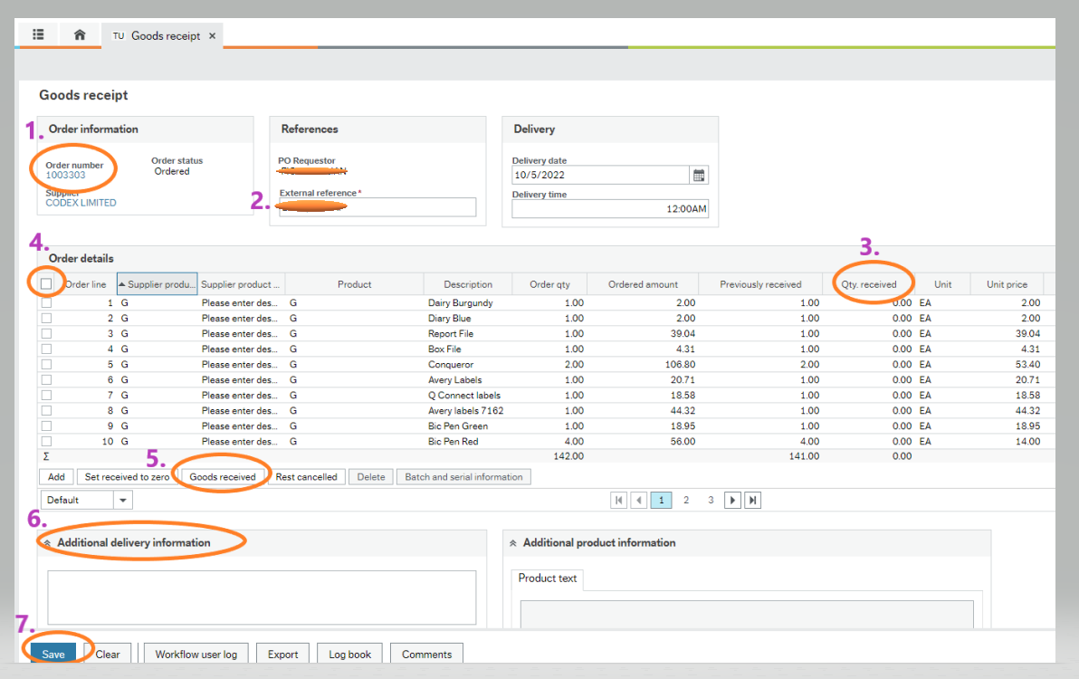

If an invoice is submitted to Accounts Payable requesting payment where a purchase order has not been confirmed as delivered by a GRN, you will be alerted through your tasks of a Missing GRN

# **To generate a GRN from a Task Alert**

* Go to your Tasks in Agresso
* Select the item - Missing GRN – Trans No- Supplier Name
* Click on Goods receipt
* Complete the GRN as outlined in the Steps above
* Click on Task Complete