**AGRESSO GUIDE -**

**TASKS FOR BUDGET HOLDERS**

**Email Notification**

When you have a Task awaiting approval, you will receive an email from **Agresso** alerting you that there is a new item in your task list for approval.

**Opening Agresso on the Web**

The system can be accessed by clicking on the following link [Agresso Web](https://s-eu-ids1.unit4cloud.com/identity/Account/Login?ReturnUrl=%2Fidentity%2Fconnect%2Fauthorize%2Fcallback%3Fclient_id%3Die_tus_prod_web%26response_type%3Did_token%26scope%3Dopenid%2520profile%26redirect_uri%3Dhttps%253A%252F%252Fubw.unit4cloud.com%252Fie_tus_prod_web%252FLogin%252FLogin.aspx%253FReturnUrl%253D%25252fie_tus_prod_web%25252f%26state%3Dedd8ce33228c4995b92b7340436f23f9%26nonce%3Db050b2687029457882a177a4f0bf5a17%26acr_values%3Dtenant%253A93f804ec-87dc-4207-b2c4-2cfcdcd5e8ed%2520loginidp%253A%26response_mode%3Dform_post)

The link is also available in your email notification.

You will not need a separate password.  Sign on is authenticated via your TUS e-mail account.

**Tasks Area**

When items are awaiting approval, they will appear in the ‘Your tasks’ area which is the home screen (1st tab) of your Workspace.

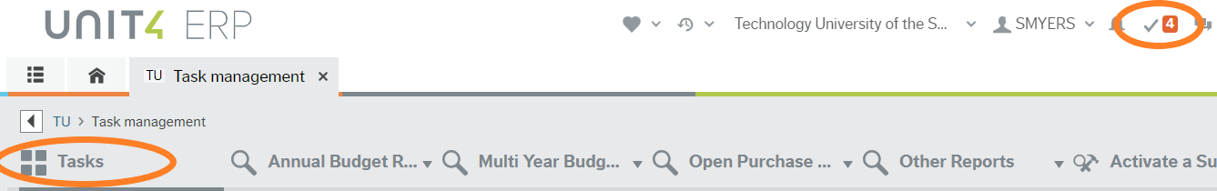

Tasks can also be accessed from the top right corner of the screen, look for a tick mark with a number highlighted in orange.

**Requisition Approval Tasks**

* **Purchase Approval** is a Requisition which awaits your approval. A Requisitions is converted to a Purchase Order once fully approved. A Purchase Order is then emailed to the Supplier.

**Invoice Approval Tasks**

* **Service Invoice Approval (matches PO)** will be sent to the Requisitioner and then to you the Budget Holder to confirm that the service was received and to **accept/reject** the invoice.
* **Service Invoice (exceeds PO)** will be sent to the Requisitioner and then to the Budget Holder to confirm that the service was received and to **accept/reject** any price difference from the original order.
* **Goods Invoice (exceeds PO)** will appear in your tasks if there is a difference in the price between the Invoice and Purchase Order.  All such mismatches will be sent to the person who created the requisition first, to facilitate detailed checking.

It will be clear from the description within your Task List which type of approval is required.

**Approve**

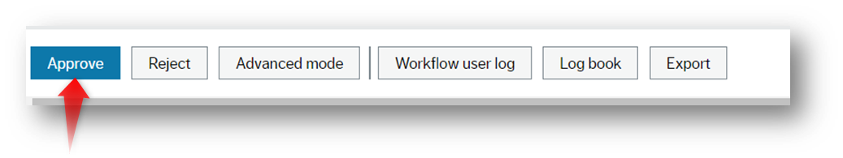

**Reject**

The approver can reject a task but must enter a comment. The item will route back to the Requisitioner or to Finance for amendment/closing.

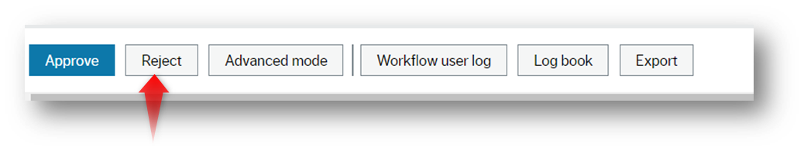

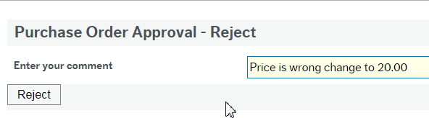

For Agresso Support queries, please contact: [AgressoSupport@tus.ie](mailto:AgressoSupport@tus.ie)